**CREATIVE PORTUGAL, IT’S TIME TO WIN!**



What would you do if someone told you that your TIME TO WIN is coming? Most likely, you’d ask when and where. If you’re a creative, the answers are no doubt April 15-17 and Minsk – the dates and venue of **XIIth International advertising festival** [**White Square**](http://adfest.by/en).

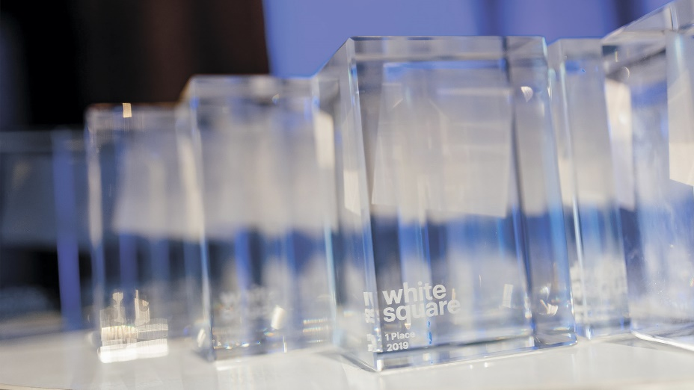This creative award show holds strong positions in Eastern European festival rankings and has a reputation of some kind of a springboard to success for talented advertisers that already highlighted a number of well-known names, agencies and projects in the world of communications. Opening festival year in Europe and having real stars of global industry with tones of prestigious metals under their belts as jury members, White Square gives their first portion of international fame to the best entries executed both by large network agencies and smaller independent ones. Prize winners of the festival are annually promoted on over 30 industrial media of Western and Eastern Europe, including [t](https://youmark.it/), [imagensdemarca.pt](http://www.imagensdemarca.pt), [marketingdirecto.com](http://www.marketingdirecto.com), [adforum.com](http://www.adforum.com), [marketing365.mk](http://www.marketing365.mk), [iqads.ro](http://www.iqads.ro) etc.

Recognized as a must-see European creative event and attended by a bench of famous and awarded ad men such as **Matthias Harbeck** from Serviceplan Germany, **Evgeny Primachenko** from Wieden+Kennedy Amsterdam, **Malek Ghorayeb** from Leo Burnett Beirut, **Vicky Gitto** from ADCI, **Juan Garcia-Escudero** from Leo Burnett Madrid, **Nuno Jeronimo** from O Escritorio, **Tristan Macherel** from Landor Europe and many more, White Square already for a while serves as a creative hub providing ad professionals with possibility to welcome brightest creative minds from 30 countries, exchange creative thoughts and get inspired by unique creative works from yet unfamiliar region, explore the newest trends and most promising ads from all around the globe on the very start of new creative season.

To name a few, on the list of White Square 2020 [jurors](http://adfest.by/en/jury-c-20) are:

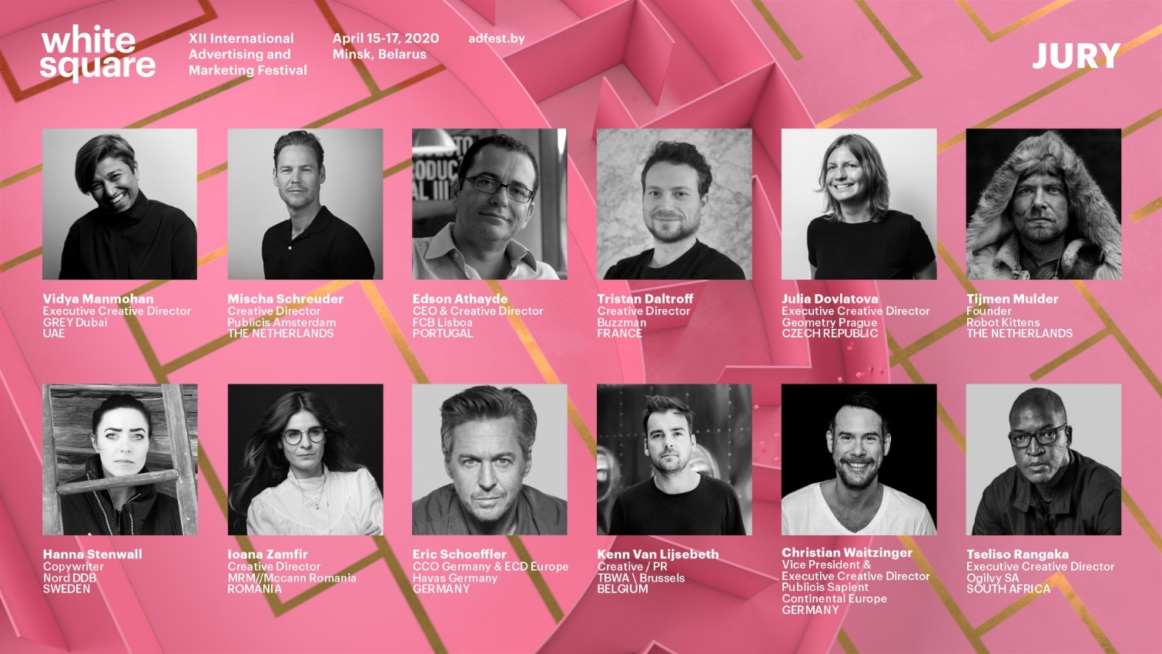

The call for entries to White Square 2020 is now open. Deadline – March 27.Creative works are easy to submit online on official website [adfest.by](http://www.adfest.by). There are just three simple steps on the way to the judging room.

1. Login on White Square official website [adfest.by](http://www.adfest.by) and fill in some basic information
2. Choose most suitable [contests](http://adfest.by/en/contests) and nominations:

**CREATIVE**: Film, Print, Radio & Audio, Outdoor, Integrated, Branded Content and Entertainment;

**BRANDING**: Communication Design, Packaging Design, Digital & Interactive Design;

**MARKETING**: Brand Experience & Activation, PR, Direct, Innovations;

**CREATIVE EFFECTIVENESS**;

**MEDIA**: Channels, Excellence in Media, Media Campaign;

**DIGITAL**: Digital, Mobile, Creative Data;

**CHANGE FOR GOOD**.

1. Prepare and upload your entries in your personal account.

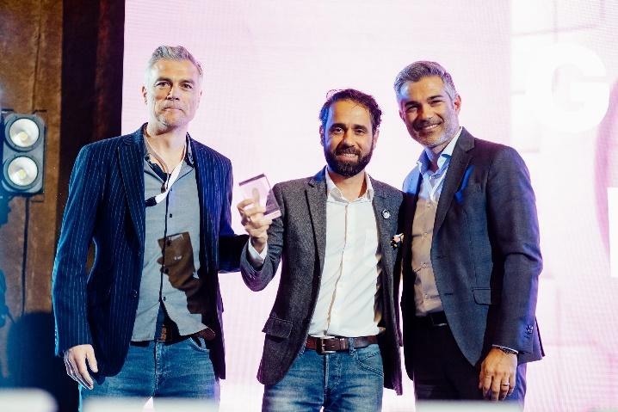Good news is that participants who submit five or more entries to White Square 2020 will get a full entry pass to all events of educational and cultural program of the festival. White Square’s business and educational [program](http://adfest.by/en/delovaya-i-obrazovatelnaya-programma) will continue during three whole days – April 15, 16 and 17 – and include over 70 master-classes and discussion panels devoted to creative trends in communications, marketing, branding, digital, media and held by stars of global ad industry. Parties will complete every festival day.

Minsk, Belarus is open and visa free for the Portuguese, as well as always ready to offer lots of original travel experience filled with high tech and IT innovations and authentic remains of traditional local lifestyle based in small picturesque country almost in the very heart of Europe full of green forests, blue lakes and friendly people.

Detailed information about White Square festival is provided on official website [adfest.by](http://www.adfest.by). For participation in the contests contact the Directorate of the Festival – [Association of Communications and Marketing Agencies of Belarus](http://association.by), member of EACA, via [konkurs@adfest.by](mailto:konkurs@adfest.by); for participation in business and educational program – via [info@adfest.by](mailto:info@adfest.by).